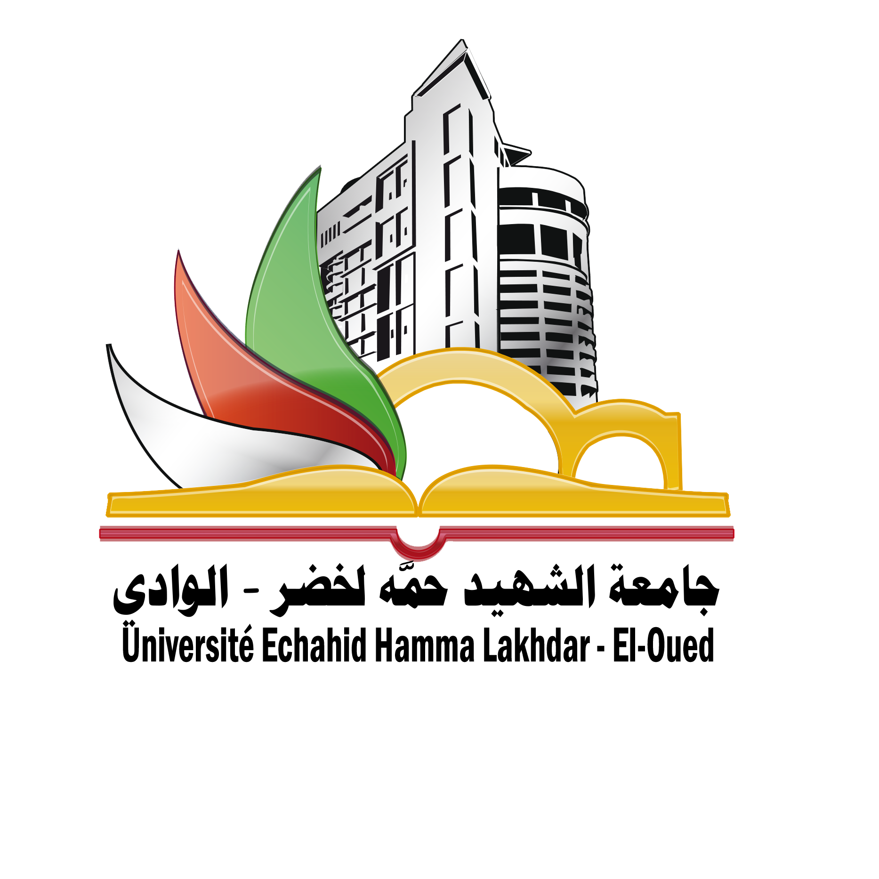
مكتب برامج ايراسموس +
جامعة الشهيد حمة لخضر- الوادي
نيابة المديريـة المكلفـة بالعلاقات الخارجية والتعاون

Required documents

For students:
- Cv Europass
- Copy of passeport
- Certificate of enrolment for the current academic year
- Invitation letter for PhD.
- Points statements for the course of study
- Copy of diploma
- English certificate level (minimum B2)
- Motivation letter.
- Research Plan for PhD
- Application form (see attached files)

For Teachers:
- Cv Europass
- Copy of passeport
- Teaching Content
- English certificate level (minimum B2)
- Application form (see attached files)

For staff:
- CV Europass
- Copy of passport
- Motivation letter
- English certificate level (minimum B2)
- Application form (see attached files)

